**Data Analysis of Temperature Data from Iot Sensor**

|  |
| --- |
|  |
|  |  |
|  |  |

**Architecture:**

EC2(python script for temperature sensor iot data) ----> Kinesis stream ---->Kinesis Analysis(anomaly detection)---->kinesis firehose----->Elastic search domain ----> Kibana Visualization

**Intallations**:

1) putty

2)boto

3)awscliv2

**STEPS:**

1. Create Kinesis stream

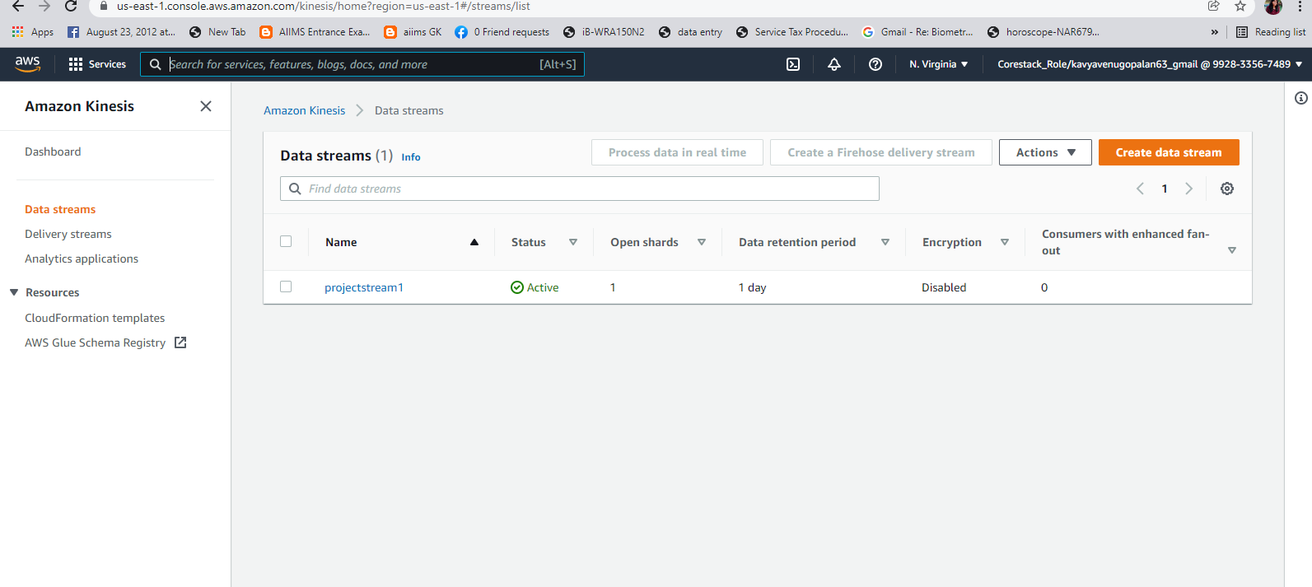

1. Launch Linux EC2 instance and modify IAM role.

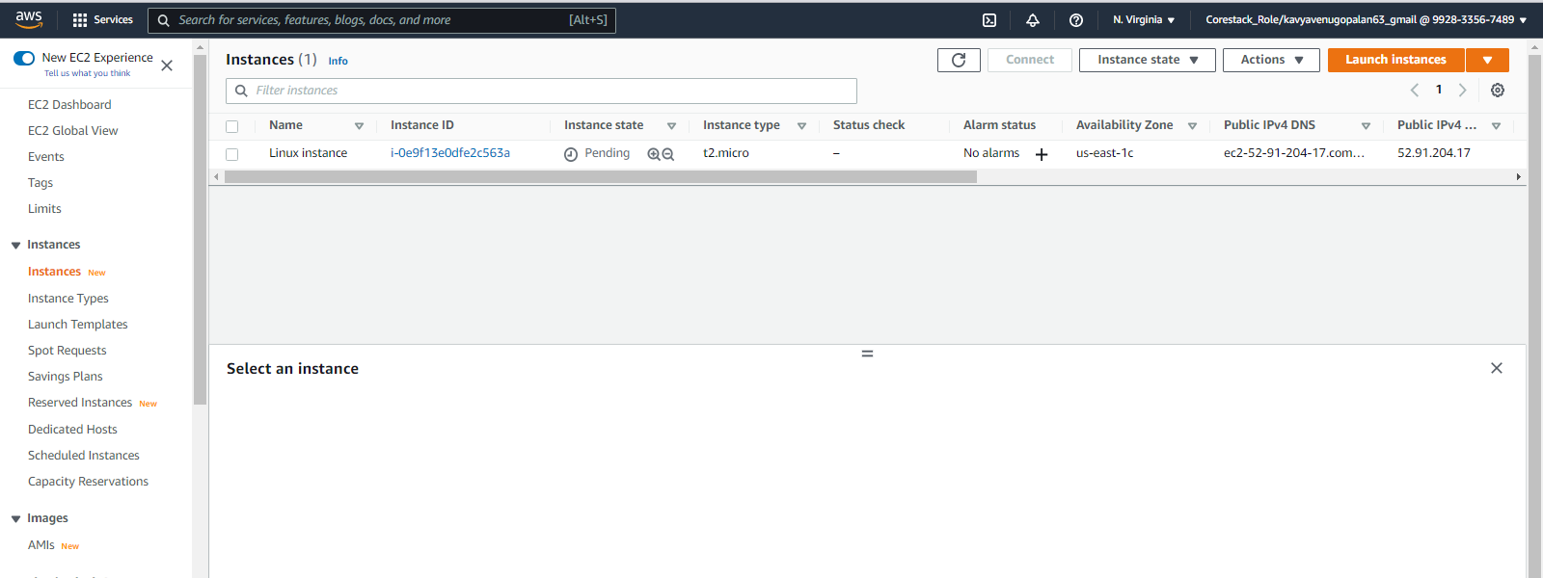

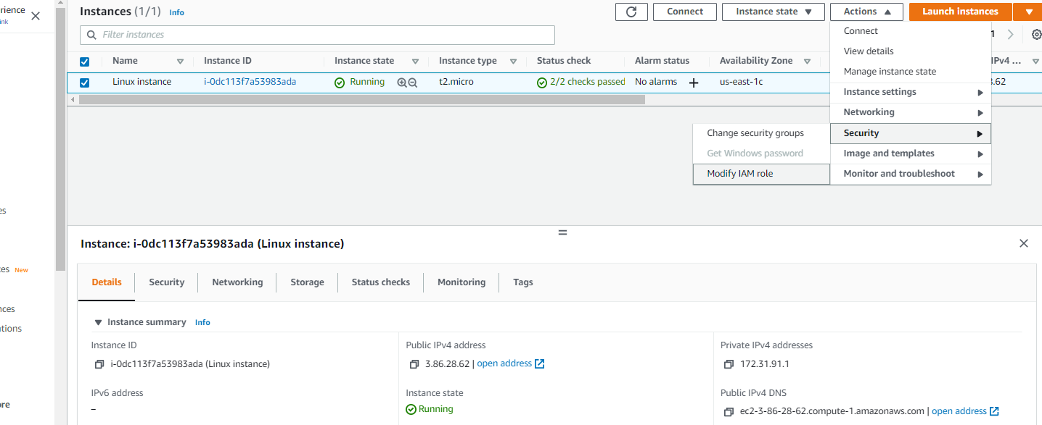

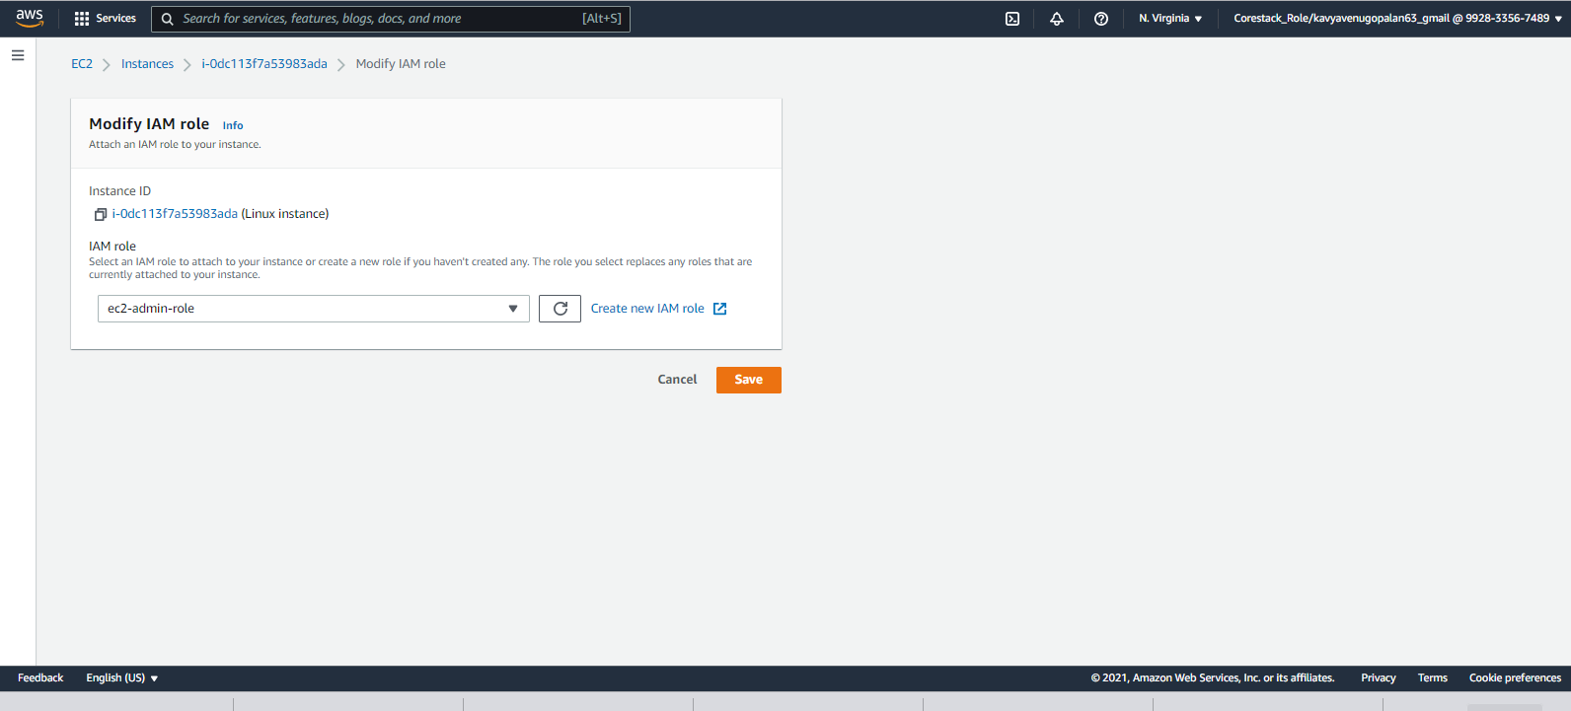

1. Use putty to access cli of linux instance.

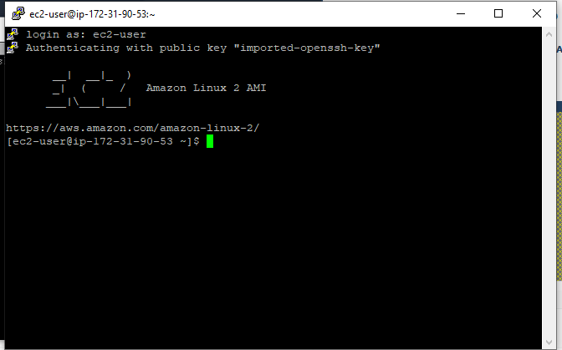

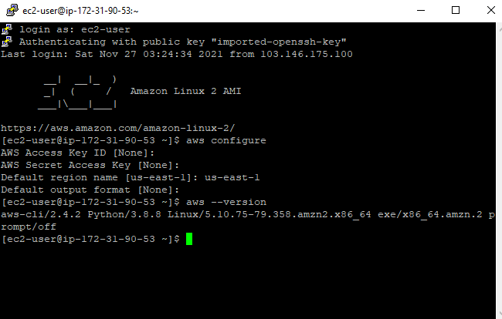

1. Create opensearch from cli of ec2 instance using the following command.

/usr/local/bin/aws opensearch create-domain --domain-name my-transcribe-test

--engine-version OpenSearch_1.0 --cluster-config InstanceType=t2.medium.search,InstanceCount=1

--ebs-options EBSEnabled=true,VolumeType=standard,VolumeSize=10 --access-policies

'{"Version":"2012-10-17","Statement":[{"Effect":"Allow","Principal":{"AWS":"arn:aws:iam::992833567489:root"},

"Action":"es:*","Resource":"arn:aws:es:us-west-2:992833567489:domain/my-transcribe-test/*"}]}' --region us-east-1

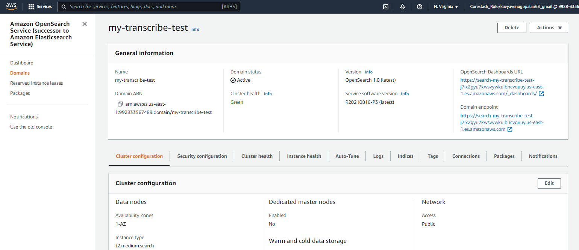

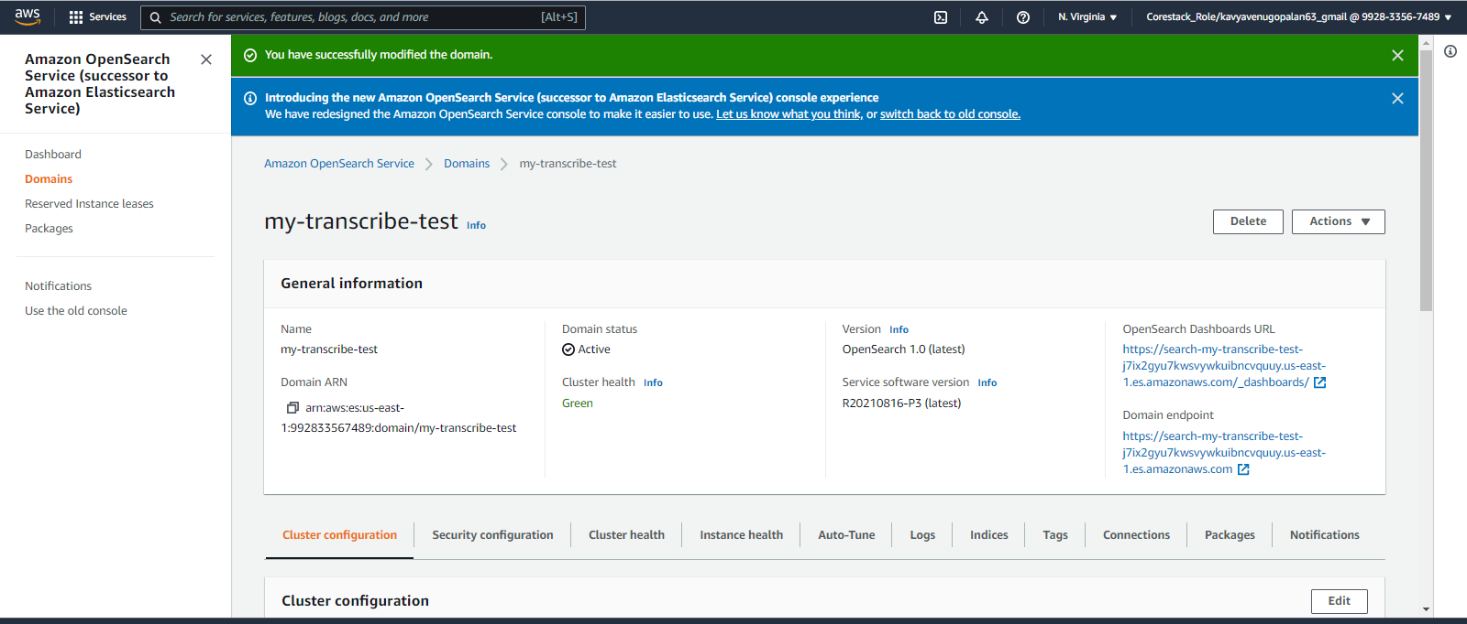

1. Configure security of domain

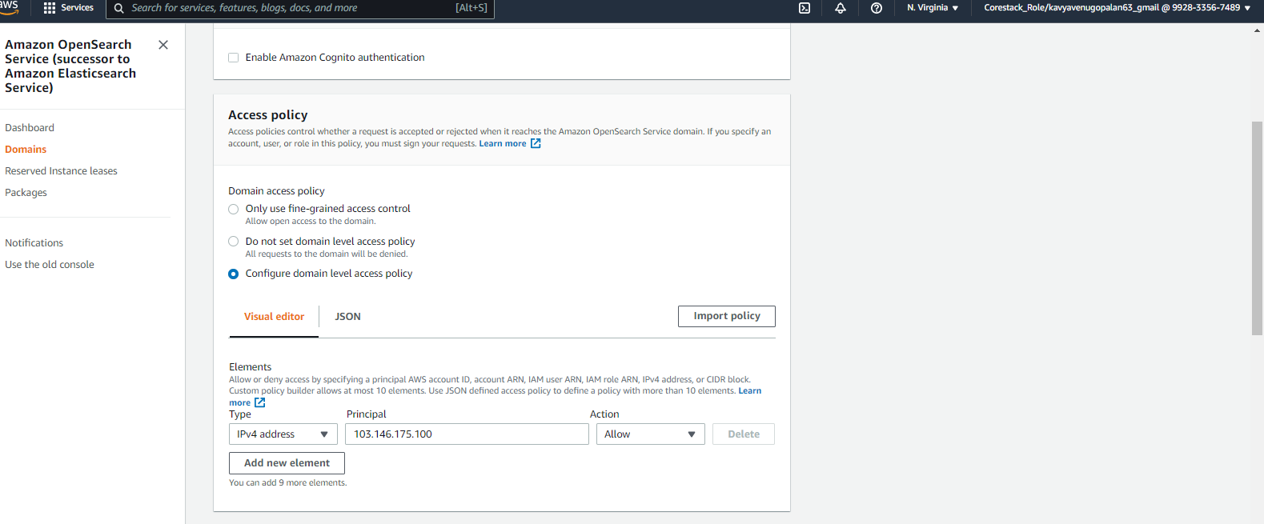

1. Create Kinesis Firehose that sends data to opensearch.

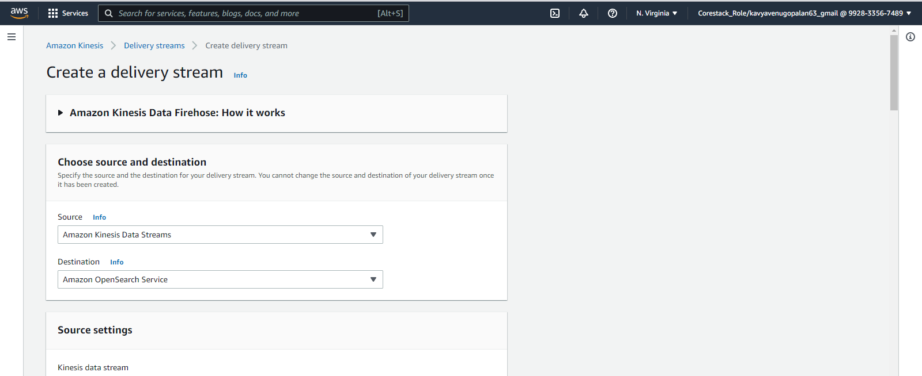

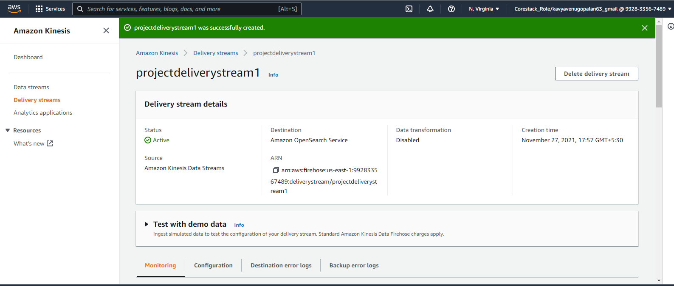

1. Run the provided python program(temperature.py) to generate data from iot temperature sensor and stop after a while

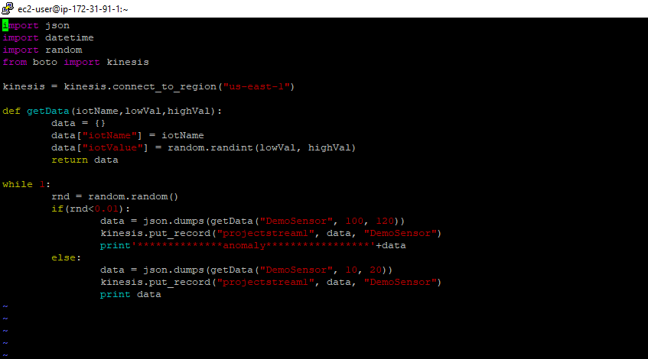

Python code running

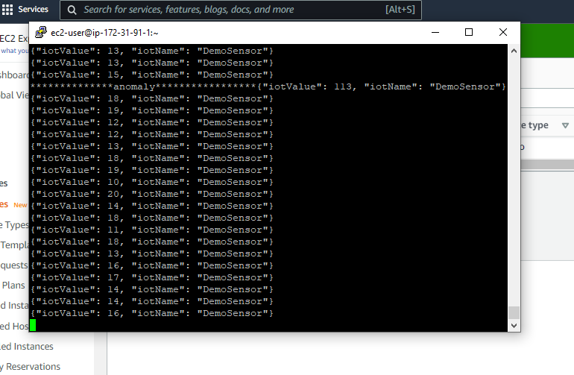

1. Create Kinesis Analytics Application

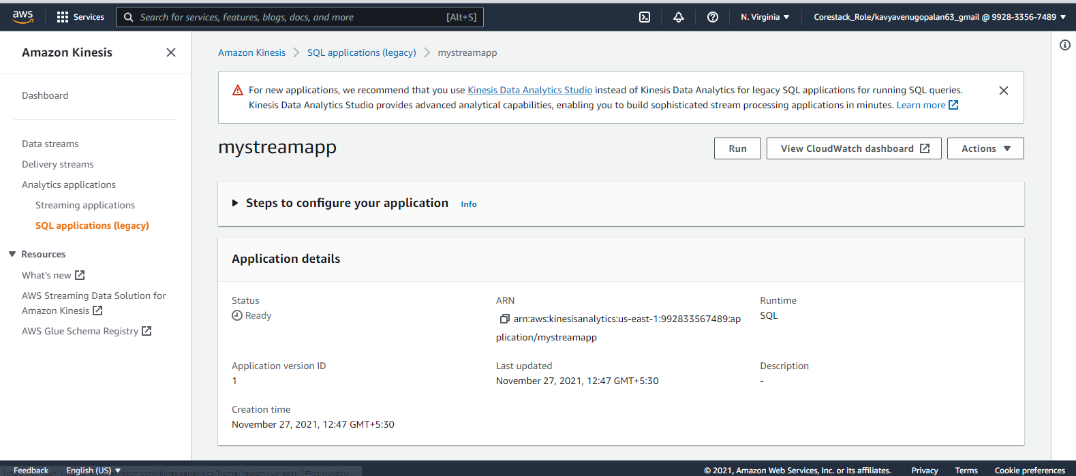

- Configure Source, Real-Time Analytics with sql code provided, Destination

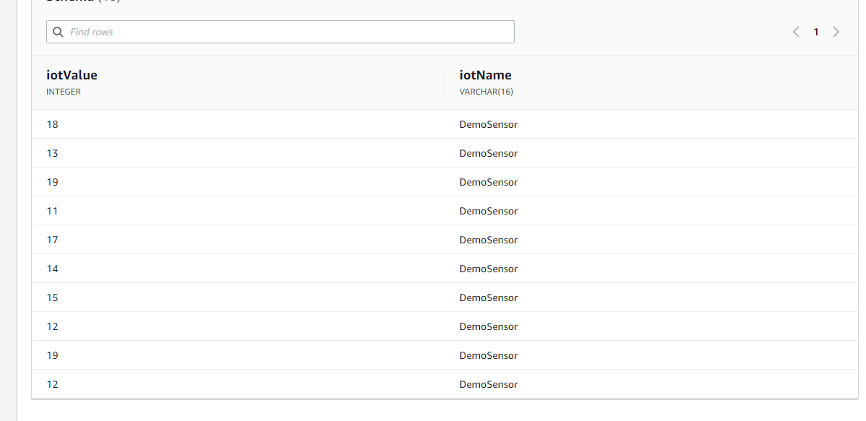

(Schema)

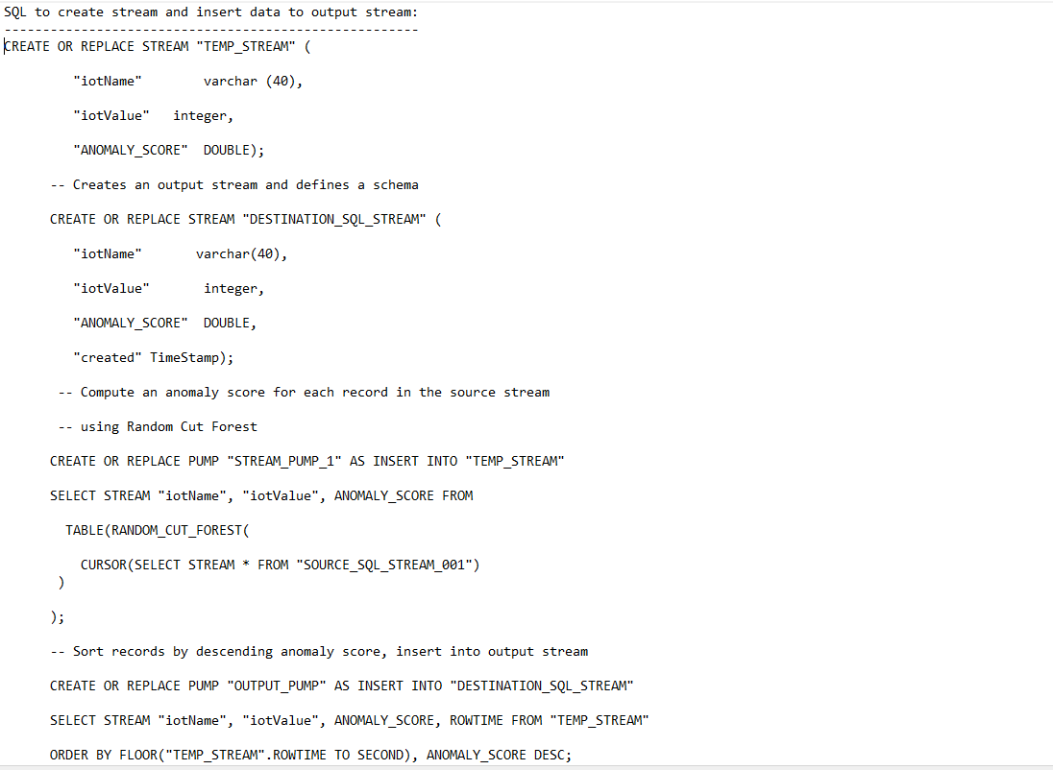

(query is provided in github)

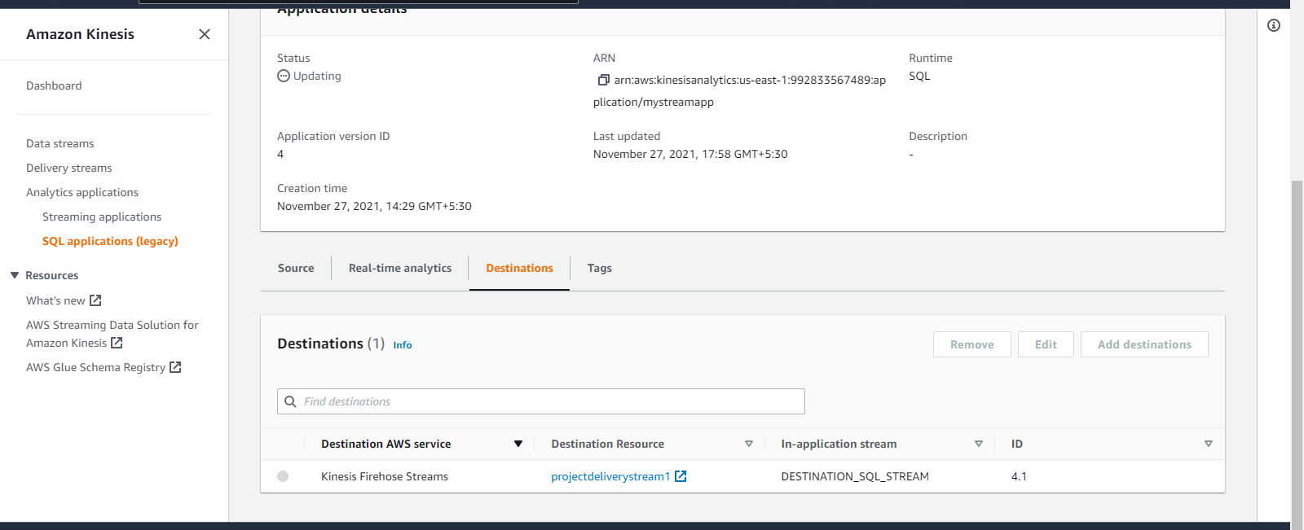

(destination)

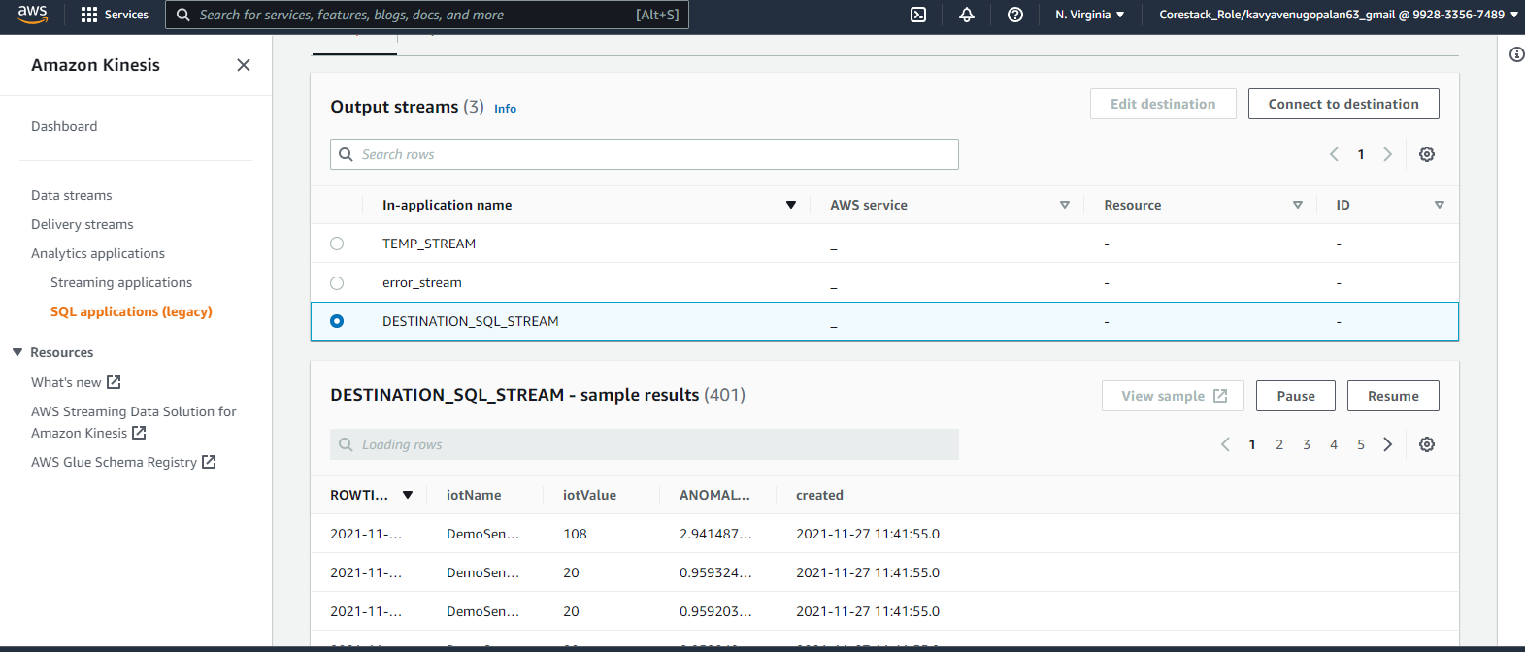

(output stream after running sql query)

1. create index pattern in kibana, open dashboard

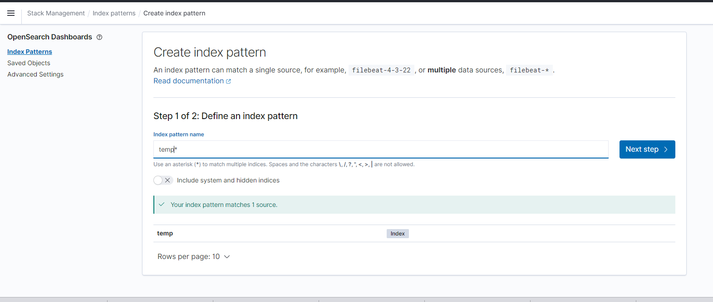

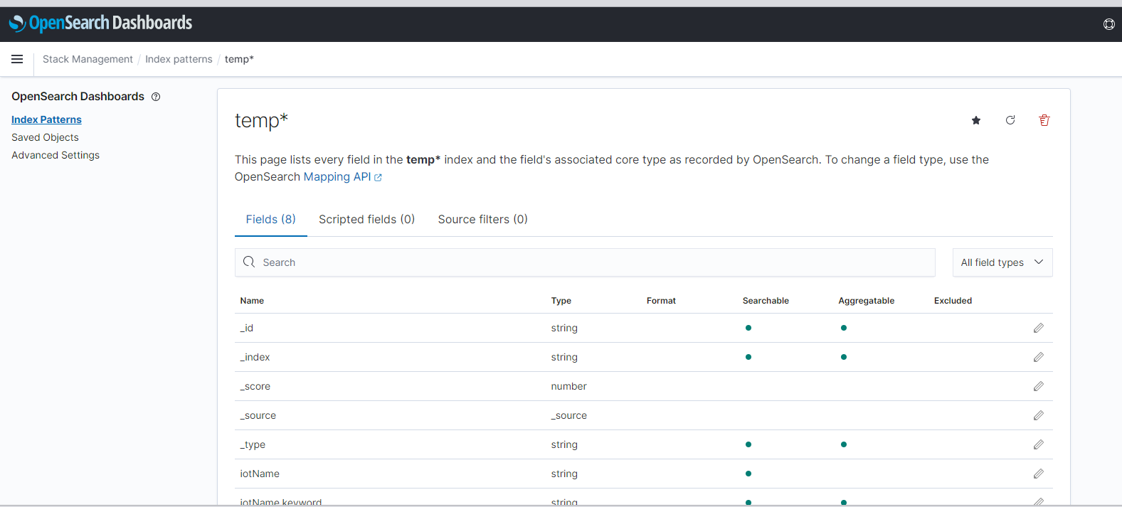

1. Visualize data

